General Description
This document describes how to build and develop Metamask Gardio Snap
Contents
General Description 1
1 Prerequisites 3
1.1.1 Install Node and npm 3
1.1.2 Install yarn 3
1.1.3 Versions 3
2 Gardio Snap 4
2.1 Clone the repository 4
2.1.1 Github Repo 4
2.1.2 npm package 4
2.2 Build 4
2.2.1 Yarn install ( Development build) 4
2.3 npm publish ( Production build ) 5
2.3.1 Update the Snap Version 5
2.3.2 Build the Snap 5
2.3.3 Login to npm 5
2.3.4 Publish to npm 6
3 Gardio Dapp 7
3.1 Clone the repository 7
3.1.1 Github Repo 7
• https://github.com/ThirdWayv/gardioMetaMaskSnap 7
3.2 Build 7
3.2.1 Yarn install ( Development build) 7
3.3 Dapp Deploy ( Production build) 8
3.3.1 Build the dApp 8
3.3.2 Ensure Firebase Tools are installed 8
3.3.3 Login to Firebase 8
3.3.4 Deploy to Firebase 8
4 Build Wasm 9
4.1 Prerequisites 9
4.1.1 WSL 9
4.1.2 Emscripten 9
4.2 Build 9
5 Solana Support 12
5.1 Support in WASM 12
5.2 Set Solana Explorer 12
5.3 Solana Transaction 12
6 References 14
6.1 MetaMask 14
6.1.1 Snap Document 14
• https://docs.metamask.io/snaps/ 14
6.1.2 Snap Simple MetaMask Example Repo 14
6.2 Jira Tickets 14
6.3 Wasm 14
6.4 Solana Support 14

Prerequisites

Install Node and npm
- Download and install Node.js
  - https://nodejs.org/en
  - This will also install npm (Node Package Manager).

- To verify the installation, run these commands
  - node -v
  - npm -v

Install yarn
- Node & npm should be installed first
- Run this install command in the terminal
  - npm install -g yarn
- To verify the installation, run these commands
  - yarn -v

Versions
- We build the Snap and the Dapp with
  - yarn version 3.6.3
  - node version 22.16.0 ( >= 18.0.0 )
- Run this command to set our package.json version
    - yarn set version 3.6.3
- Verify the versions of node and yarn as in the package.json of your project
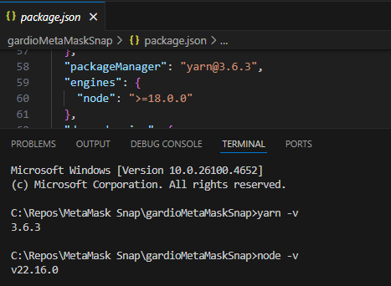

Gardio Snap

Clone the repository

Github Repo
- https://github.com/ThirdWayv/gardio-metamask-snap

npm package
- https://www.npmjs.com/package/@gardio/gardio-snap

Build
- Clone the GitHub repo
- Add the folder to VS Code workspace
- Open Visual Studio Code terminal for this folder
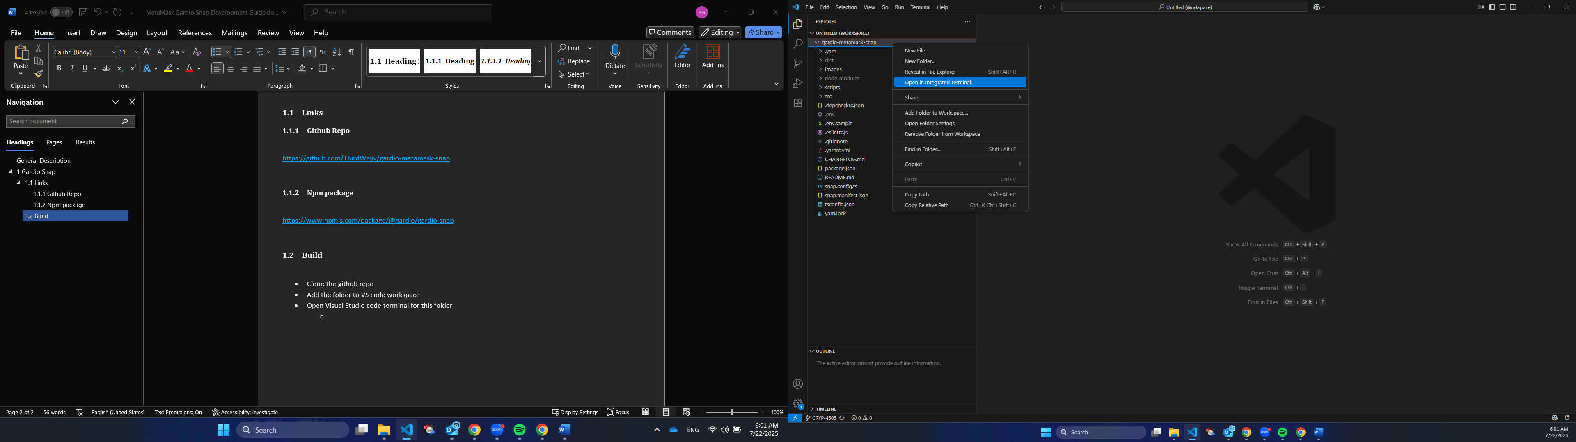

- As default terminal in VS Code will open as PowerShell
  - You will need to switch to Command Prompt ( CMD)
  - You can make it the Default terminal for VS Code
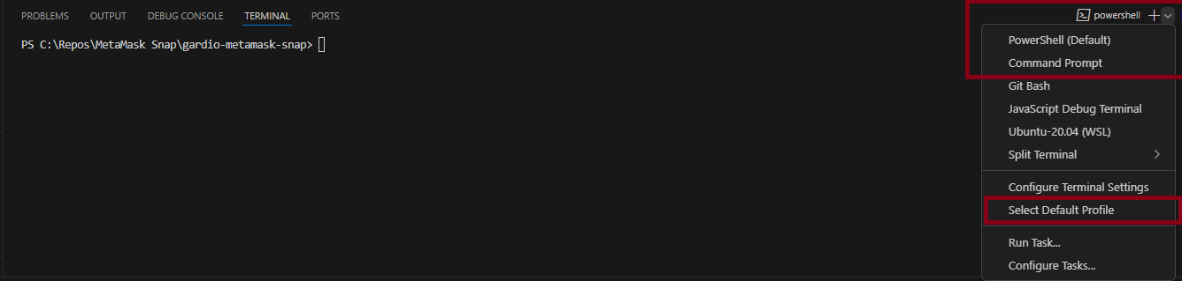

Yarn install ( Development build)
- Run this command first
  - yarn
  - the expected output:
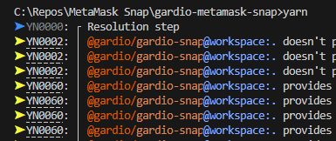
- Run this command to start developing
  - yarn start
  - the expected output:
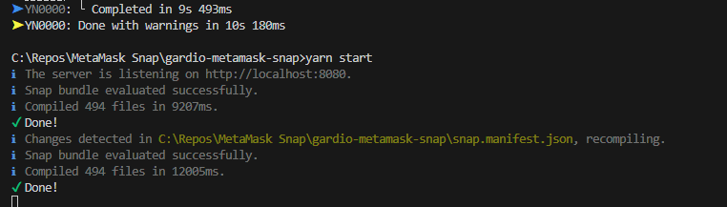
  - When you develop the code, the terminal will detect the change automatically and recompile

npm publish ( Production build )

Update the Snap Version
  - npm does not allow publishing the same version twice.
  - Before publishing, update the version in both:
    - package.json
    - snap.manifest.json
  - Ensure the version numbers match exactly in both files.
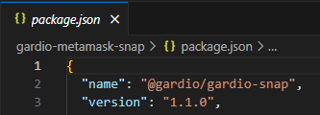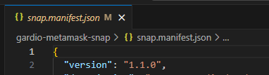

Build the Snap
- Run this command to build snap
  - yarn build

Login to npm
- You only need to log in once per environment or if you’ve been logged out.
- We use the following credentials for publishing:
  - Email: software.team@thirdwayv.com
  - Username: thirdwayv_developer
- To log in, run:
  - npm login

Publish to npm
- Run this command to npm publish
  - npm publish

Gardio Dapp

Clone the repository

Github Repo

https://github.com/ThirdWayv/gardioMetaMaskSnap

Build
- Clone the GitHub repo
- Add the folder to VS Code workspace
- Open Visual Studio Code terminal for this folder

Yarn install ( Development build)
- Run this command in this path in the repo “gardioMetaMaskSnap/packages/site”
  - yarn

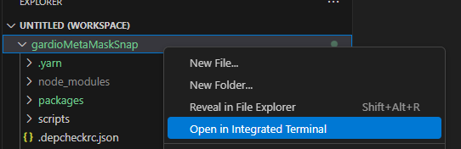
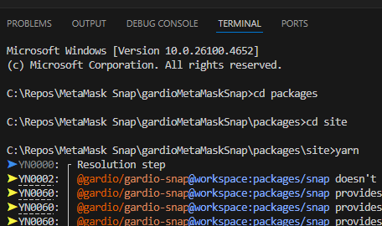

- Run this command and open the local Dapp link
  - yarn start
  - http://localhost:8000/

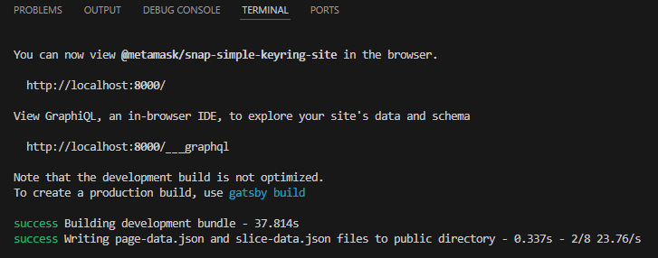
- Then go to “gardio-MetaMask-Snap-Guide” Document to know how to use it

Dapp Deploy ( Production build)

Build the dApp
- yarn build

Ensure Firebase Tools are installed
- yarn add -g firebase-tools

Login to Firebase
- You only need to do this once per environment or if you're logged out.
- We are using omar.sabry@thirdwayv.com for deploying to Firebase.
  - Firebase login

Deploy to Firebase
- firebase deploy

Build Wasm

Prerequisites

WSL
  - Must have WSL first
  - If you don’t have it, follow this document
    - https://thirdwayv.atlassian.net/wiki/spaces/CRYP/pages/2840461313/Automation+test+bringup

Emscripten
  - Clone the Emscripten SDK
    - https://github.com/emscripten-core/emsdk
  - Open WSL terminal in emsdk path and run
    - ./emsdk install 3.1.64
    - ./emsdk activate 3.1.64
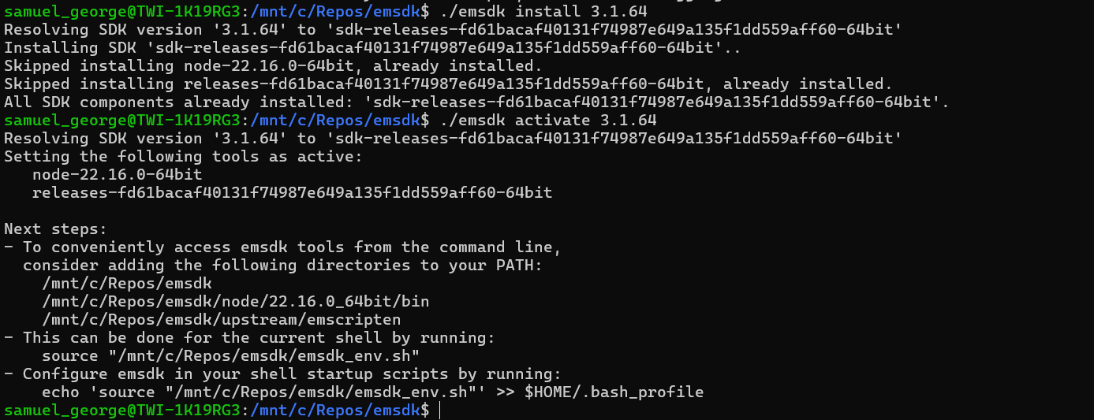

Build
- Go to emsdk path and open WSL terminal
- Run this command
  - source emsdk_env.sh
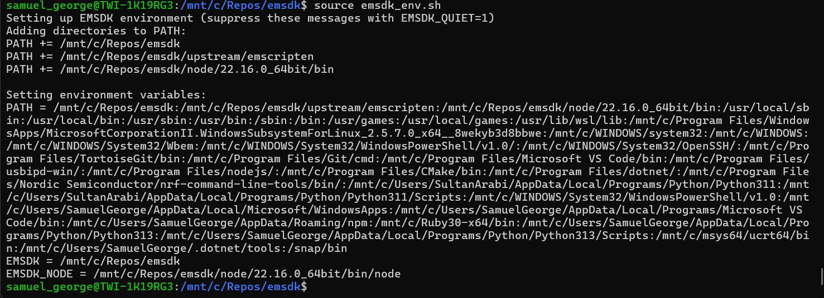
- Go to the MetaMask snap CMake Path in the WalletCore “WalletCore/Build/MetaMask Snap”
  - You will find the correct path and CMake file that builds in CRYP-4449 Branch only
  - https://github.com/ThirdWayv/TWIWalletCore/tree/CRYP-4449
- Ensure you’re in the same terminal where you’ve run this command “source emsdk_env.sh”
- Run cmake command
  - emcmake cmake
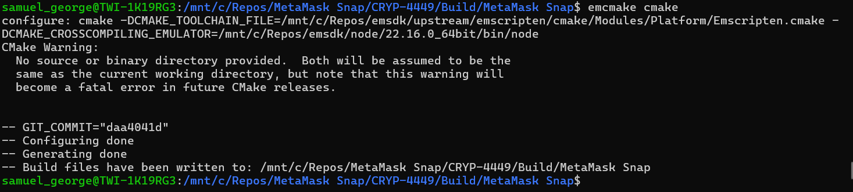
    - If you run into this error, you need to clean up first
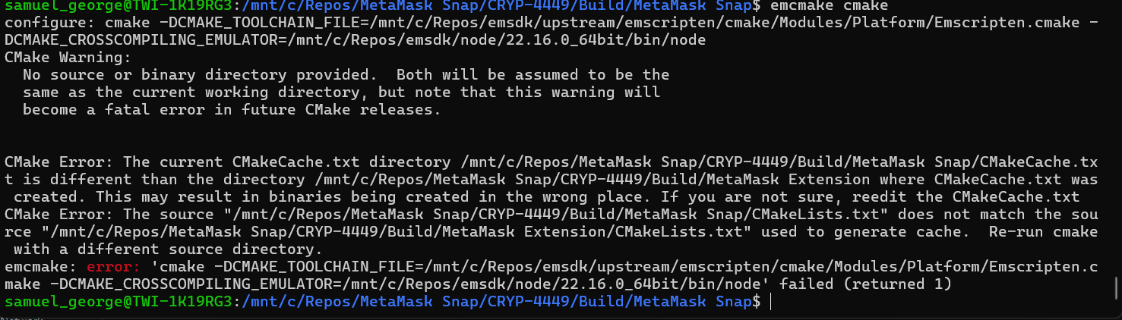

- Run make command
  - make -j20
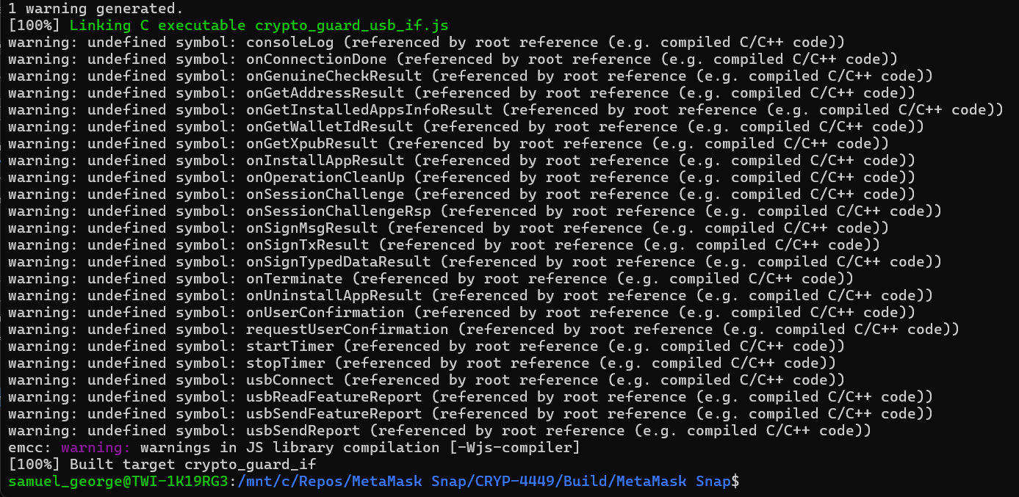
    - You will find all callbacks that WASM needs the app to implement
- Then you will find the wasm in the same path “WalletCore/Build/MetaMask Snap”
- Copy “crypto_guard_usb_if.wasm” to Dapp path
  - “gardioMetaMaskSnap\packages\site\public”
- Rebuild the Dapp

Solana Support

Support in WASM
- You will need to define `SOLANA_SUPPORTED` flag in CMakeLists.txt
- Add `twi_solana_json_parser` in the paths
- Exist in Branch CRYP-4449 in WalletCore
  - https://github.com/ThirdWayv/TWIWalletCore/tree/CRYP-4449

Set Solana Explorer
- In branches that have .env.sample as CRYP-4449 & CRYP-4505 will need to copy it and rename with .env
- Then set the Solana explorer RPC URL
- If the branch doesn’t have .env.sample, so no Solana and no need for .env
- Then build the snap
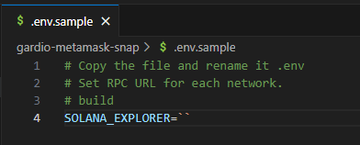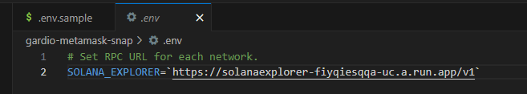

Solana Transaction
- Solana Transactions is not supported yet in MetaMask for the Non-EVM snaps, as the gardio snap
- Need to build extension and comment the block in the Metamask extension
- https://github.com/MetaMask/metamask-extension
- Open tags and the latest metamask flask extension version is 12.22.2, and not support solana tx yet
- Download source code to build
  - Go to Metamask Extension Development Guide
  - Remove this block
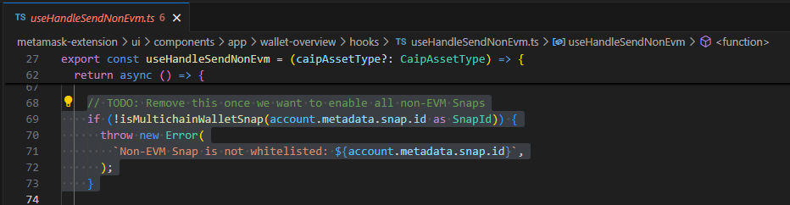
- Or can just download the output extension and remove the block in the output extension
  - Download Metamask-flask-chrome-12.22.2
  - Remove this line
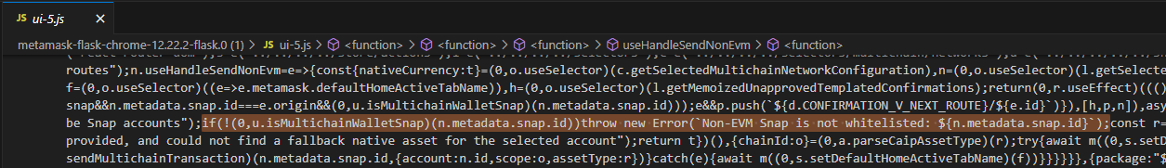
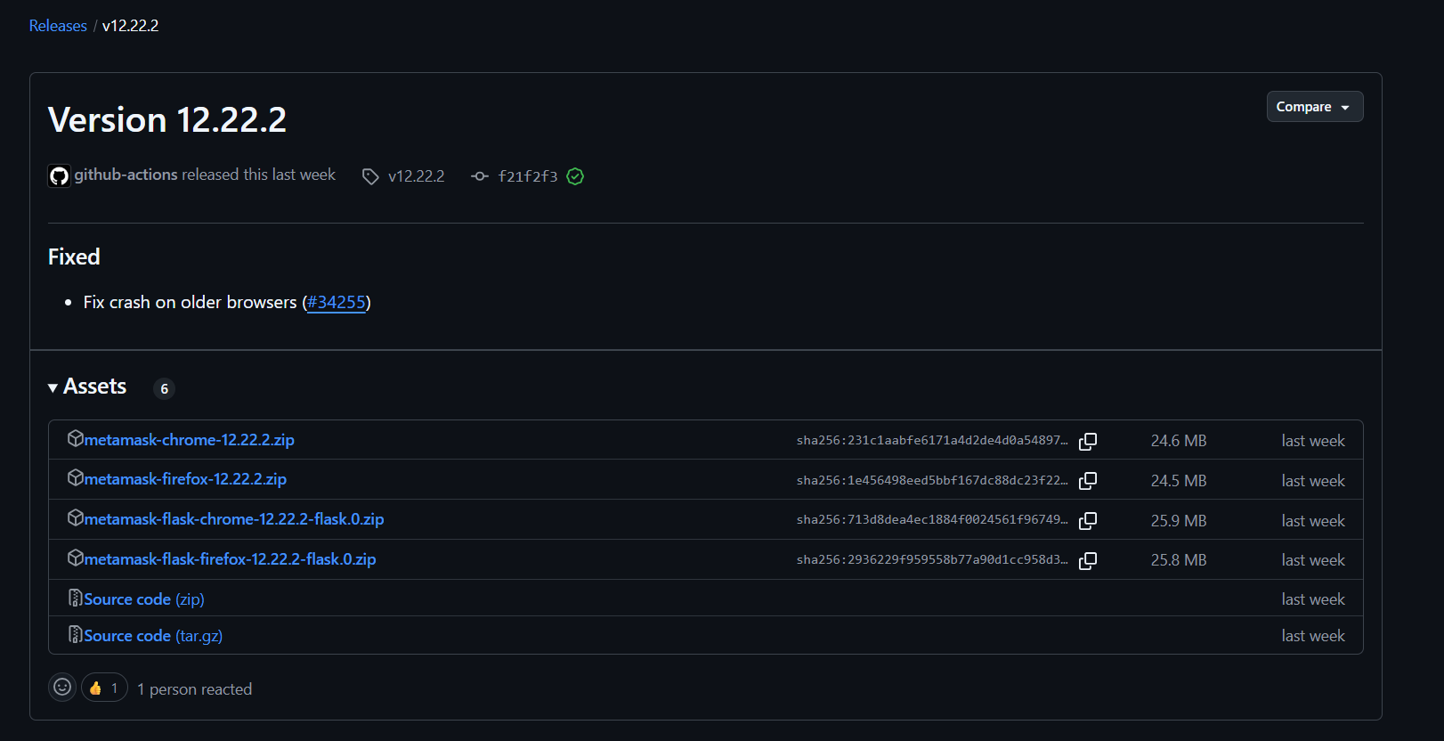
- Then, Solana transaction flow is not documented yet in Metamask documentation
- But there is an example repo for Solana official by MetaMask that can be a reference
  - https://github.com/MetaMask/snap-solana-wallet
- All Jira tickets that you need to review before starting to develop the Solana transaction in the snap
  - https://thirdwayv.atlassian.net/browse/CRYP-4440
  - https://thirdwayv.atlassian.net/browse/CRYP-4449
  - https://thirdwayv.atlassian.net/browse/CRYP-4505
  - https://thirdwayv.atlassian.net/browse/CRYP-4504

References

MetaMask

Snap Document

https://docs.metamask.io/snaps/

Snap Simple MetaMask Example Repo
- https://github.com/MetaMask/snap-simple-keyring

Jira Tickets
- https://thirdwayv.atlassian.net/issues/?jql=project%20%3D%20%27CRYP%27%20AND%20textfields%20~%20%22MetaMask%20Snap%22

Wasm
- https://github.com/emscripten-core/emsdk
- https://thirdwayv.atlassian.net/wiki/spaces/CRYP/pages/2840461313/Automation+test+bringup

Solana Support
- https://github.com/MetaMask/snap-solana-wallet
- https://www.npmjs.com/package/@metamask/solana-wallet-snap

